http://www.jamesflint.net/looking-for-acord Looking for Acord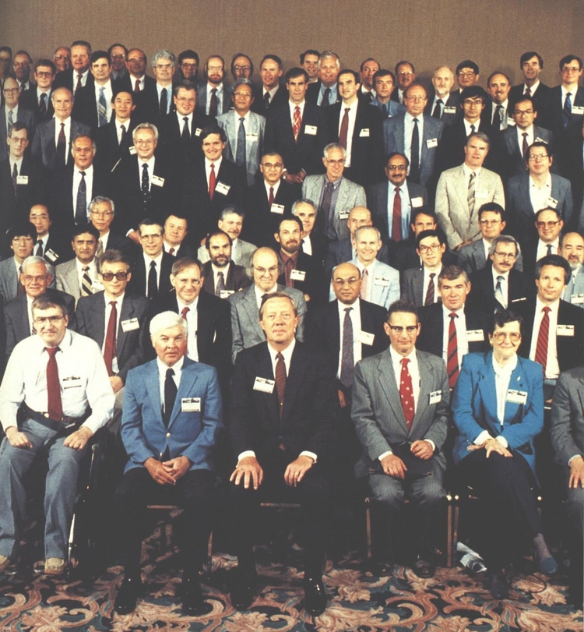
The artist James Acord (front row, second from right) at the Fast-Flux Test Reactor conference, Richland, WA
A small industrial unit situated at the junction of a highway and a railroad seems an odd place, in these days of vast military-industrial operations, for the setting of one of the defining stories of the nuclear age. But the highway leads into the town of Richland, which in 1943 was transformed by government order from a tiny farming community into a vast, semi-permanent camp housing some 50,000 workers, while the railroad curves off into the desert and terminates somewhere close to B-reactor, built in an astonishing 13 months during World War II, and designed - along with the rest of an enormous production complex - to produce the plutonium needed for the 'Fat Man' type A-bombs used for the Trinity test and dropped on Nagasaki. Which means that the industrial unit is the home and studio of James L. Acord, sculptor, possibly the world's smallest (official) nuclear power and the man who wants to create a monument to the technology which in many ways has come to symbolise the twentieth century itself.
Building monuments is something that James Acord knows a thing or two about. A largely itinerant artist throughout the sixties and seventies, during the 80s he added the stonecarver's trade to his list of skills, cutting plaques and gravestones to see himself through lean financial times. Born in Seattle in 1944, he ran away from home aged 15, a copy of Kerouac's The Dharma Bums sticking out of his back pocket, dreaming of travelling to Italy and becoming a painter. He made it as far as Cherry County, Nebraska, where he worked for a while as a cowboy on a relative's ranch, eventually returning to Seattle to enrol in the Cornish School of Allied Arts. Chafing as always against academia, Acord left Cornish determined to collect the skills he felt he needed as a sculptor in his own, 'hands on' way. 'I wanted to be able to identify and imagine how anything I saw was made,' he remembers. 'Everything I looked at, I wanted to know: Was it cast in a mold? Was it spun, you know being turned against a sharp object, like the way a lathe turns things? What was the process?' His quest for knowledge led him many places including, crucially, the Vermont town of Barre, home of some of the finest granite mines in America and with a community of stone carvers to match. It was in Barre that Acord became fascinated by granite, and it was through granite, bizarrely, that he first became involved in the nuclear age.
Like all granites Barre granite is mildly radioactive, containing as it does a significant amount of uranium. Uranium was much in the news while Jim was in Barre, thanks to the nuclear accident at Three Mile Island, and he became interested in the way that it formed an integral part of the stone he was learning to carve. Influenced by the old dreams of alchemy and by a stint working as a jeweller, a craft in which the setting of stone into metal is key, one of Jim's artistic aims had become the successful blending of metal and stone in a major sculptural work. And then he discovered nuclear waste.
At the time, internment in solid-granite batholiths was the favoured solution for the long term storage of unwanted nuclear material. Driven by the challenge of creating a structure that could protect its contents over a minimum period of some 25,000 years (the half-life of plutonium), Acord began to conceive of a way in which he could channel all of the apparently heterogenous skills he'd been collecting together into a single artistic trajectory. Waste storage was a job, he felt, that could not be done by science alone. In terms of a precedent, even the pyramids, at 5000 years mankind's oldest geometric artefacts, didn't measure up. The only thing that came close were the cave paintings at Lascaux, produced some 27,000 years ago. Art, it seemed, was the only thing with an adequate CV.
Drawing on the idea of the medieval reliquary - an ornamental container for a religious artefact such as a shard of the true cross or a lock of the hair of a saint - Acord began a work he entitled 'Monstrance for a Grey Horse'. It was to be carved from a single block of granite and would depict a horse's skull sitting atop of a five foot trapezoidal column, an archetypal totem of fear and death. This was appropriate, because deep inside the monolith a container of dangerous radioactive material was to be stored, making the sculpture into an actual waste depository. A metallic headpiece fitted over the skull and made of a metal transmuted in the heart of a reactor would hint as to the technical nature of the contents. As a work of art it encapsulated many of the issues and aspects of nuclear technology, while suggesting a practical solution to some of its problems. How could anyone possibly object?
Acord was about to find out. Leaving Barre and returning to the Seattle area with Monstrance in tow, he found a studio space in an artistic/industrial area called Fremont and set about obtaining some waste. 'I do have to say in all honesty that I did not understand this at all,' he confesses. 'I called up the nearest nuclear power plant and asked if they would give me some radioactive waste so that I could make sculpture out of it.' If they had any spent fuel rods lying around, he said, he'd be happy to drive down in his truck and pick them up. Not surprisingly, the phone went dead, as it did on many subsequent occasions over the next few months.
Disappointed but not dissuaded, Jim did some further research and soon discovered that a brand of ceramic tableware existed that had used uranium as a colouring agent in its glaze in the 1920s and 1930s, in the days before all uranium stocks were requistioned by the government. He 'started buying up large quantities of Fiestaware,' as the crockery was called, 'and in spite of everything you've heard about the enormous complexity of nuclear technology, I found that with these plastic salad trays purchased from a 7-11 I could actually crush up the uranium and separate it out with water, just like panning for gold.'
Having collected a small amount of orange sand, Jim took it down to the local office of Radiation Control for testing where it sent the needle of their Geiger-Müller counter off the scale. Thumbing hurriedly through their books of regulations the officials discovered that, strangely, there were no guidelines for dealing with artists trying to manufacture their own nuclear waste. They told Acord that what he was doing was classified as 'mining and milling' uranium, an activity that necessitated a US$380,000 license, guard dogs, dual cyclone fences and a lot more besides. Jim was furious. 'I said: "Hey, wait a minute, I'm buying this stuff out of second hand stores. I can't believe this!", and I spent the next year and a half trying to convince the federal government that I did not need a license to work with an uncontrolled radioactive source material in my sculpture. And of course they said "Well it's frivolous use," and I said "Frivolous! Are you kidding? Sculpture's one of our most ancient artistic undertakings. From the stone age to the bronze age, you know, sculptors have always used advanced technology to create works of art."'
The battle was on - and not only with the federal authorities. Fremont politicos who had heard what Jim was up to in their precious nuclear free zone had also decided he had to be stopped. At which juncture Jim was invited to speak in Richland, the dormitory town of the Hanford Site.
Hanford, the dirty brother of the more internationally reknown sites of Los Alamos and Oakridge, was the place where the fissile materials were produced and the mistakes were made and the waste was dumped. 'The Areas', as the site is locally known, is home to twelve fixed installation reactors, nine of which were built to produce plutonium and enriched uranium for the Manhattan project or, later, for the Department of Defense, as well an unknown number of mini-reactors developed for use in submarines and spacecraft. N-reactor, the last of the plutonium producers, was finally shut down in 1992, by which time Hanford operations had released about the same amount of radioactivity into the environment as the Chernobyl disaster. Today only two reactors remain operational, and one of those is on 'cold standby'.
Worryingly, Hanford sits astride the Columbia river,the second largest river in North America. More worringly, apart from the old reactors there are some 1400 other 'contaminated sites' in the Areas, including overloaded spent fuel stores, drums of low level waste (contaminated clothing, gloves, tools and so on), trenches filled with discarded submarines reactors and accompanying hot hulls, 828 beagle carcasses and 17 tons of their collected waste, the legacy of 25 years worth of radiation experiments, and several complexes of underground tanks containing vicious brews of every variety of radionuclide dissolved in highly radioactive sulphuric acid.
After giving his lecture in Richland, Jim took the opportunity to look around as much of the Areas as he could. Most of the reactors and processing plants have heavily restricted access and are only distantly visible from the highway, ominous and utilitarian grey hulks hunkering down beneath the vast skies that range above the steppe. One of them, however - the Fast Flux Test Facility (FFTF) - had a visitors' centre, and Jim dropped by. FFTF is an experimental sodium cooled reactor, and is regarded as one of the most advanced reactors - machines, even - on the planet, although it is currently on 'cold standby' and in danger of being permanently shut down along with the rest of Hanford's federal operated reactors.
That afternoon, looking through the display cases at examples of nuclear hardware - insulated piping, fuel tubes, steel and lead shot filled concrete - one display in particular caught Jim's eye. It was of a fuel pipe, yet it wasn't the pipe itself which attracted him. The pipe sat on a pedestal made of 316 low swell stainless steel, and the machinist had not just made the plate bevelled the edges but had put a curlicue pattern across the entire pedestal, made using a techique called knurling. Originally a way to aid distribution of lubricant between two moving parts, knurling has become a kind of mark of excellence for machinists. The fact that such care had been taken over this simple pedestal told Jim that the people who had built this reactor were not just normal construction workers; they were craftsmen of the highest order, who displayed through their work a pride and obsessive attention to detail that is rarely seen outside of medieval cathedrals. Jim, always on the look out for new skills to learn, was in love. 'I said to myself, this is where I want to learn to weld titanium and this is where I want to do zero tolerance casting. So I moved there.'
Richland was - and is - an ultra-conservative place, still emerging from decades of being at the heart of cold-war security. To obtain the knowledge he wanted, Jim soon realised he would have do more than live there - he would have to fit in. Throwing himself wholeheartedly into his new project, he cut his hair into a regulation crew cut, abandoned his artist's overalls for the nuclear engineer's uniform of shirt, tie and pocket protector, and married his then girlfriend (Margaret Morrissey, a landscape painter). Together they bought a small house and moved Jim's father up from Florida to live with them as Alzheimer's absorbed his few remaining years.
Thus prepared, Jim began to take classes in nuclear physics and radiation detection. He also joined all the societies and scientific associations he could find and persuaded many of them to let him give talks at their events. Little by little he managed to communicate his ideas about the relationship between science and art to the Richland community. After a couple of years he had become a well-known - if somewhat warily regarded - member of the community.
Then, as fate would have it, events took an extraordinary turn. A big international conference was scheduled to be held at Hanford, the FFTF Internationalisation Symposium, and Acord managed to get himself invited to speak after one of the dinners. His lecture went down a storm, especially with the Europeans who, less narrowly educated than many of the US scientists, grasped much more quickly the parallels that Jim was drawing between great art through the ages and reactor design and nuclear waste storage.
One group, from a Siemens-owned reactor project in Germany, liked the talk so much that when Jim had finished it's chief - one Herr Doktor Koop - asked him if he'd like some uranium to use in his art. 'I went to breakfast with them the next morning,' Acord recalls, 'and they had built a fast breeder reactor which because of a change in government policy was never going to run. So they were stuck with one hundred and twenty breeder blanket assemblies that were never going to be used. France had agreed to buy a lot of them but there were some surplus.' How many, Dr. Koop asked while pouring Jim coffee, did he want? It was all his dreams come true. 'So I said well, do they come in six packs? It turned out they did come in six packs, so I got a half rack [12]. And I called up the Nuclear Regulatory Commission later that day and said "You remember me?", and of course they did, and I said "The good news is I finished my Fiestaware project. But am I gonna need a license for importing a ton of uranium from Germany?" And they said "Yeah, you sure are."'
Everything changed. Just completing the required forms for the license took Jim eight months of full-time work. Monstrance and other projects languished as he turned all of his energies over to mastering nuclear bureacratese. But he wasn't worried - he had a new idea, one that overshadowed all of his other other artistic endeavours. He'd decided that he wanted to use the breeder blanket assemblies, each of which is about 14 feet long and 8 inches in diameter, at the heart of a colossal monument to the nuclear age. It would be an artistic statement on the complexities of the technology and its various impacts, an educational resource and a warning marker designed to survive for tens of thousands of years, warning future generations away from the massively contaminated Hanford Site, all rolled into one.
But getting it made wasn't going to be easy. Amongst the things Jim wanted to include in the monument were samples of transmuted materials. FFTF was not only was not only capable of creating its own fuel and manufacturing medical isotopes, but it could also transmute isotopes of one element into isotopes of another. Jim felt that this realisation of the old alchemical dream of turning base metals into gold deserved immortalisation in art. He put a proposal together and submitted it to the Department of Energy, which was at the time casting about for ways to diversify the way that FFTF was used and make the reactor pay for itself. Amazingly, the proposal was accepted. Somewhat less amazingly, a cool US$74 million was the price for carrying it out.
Not to be outdone, Jim rallied his old artist friends and they put together a tongue-in-cheek fundraiser art-show back in Seattle (the show lost US$400). But some people didn't get the joke. Environmentalist groups, angered by the fact that an artist was even considering working with nuclear technology, superglued the locks of the host building at night. Acord himself began to receive hate mail and was vilified in the local press.
The problem was not just his involvement with the nuclear establishment. For not only could FFTF transmute metals - it also had the ability to transmute the most dangerous and long-lived radioactive isotopes created at Hanford into relatively harmless substances that would only need to be stored for several centuries before they'd be safe to handle, rather than dozens of millennia. With long-term storage the only solution to the waste problem vaunted by the US nuclear industry, anti-nuclear groups have managed to back their foe into a corner by lobbying individual states to refuse the government the permission to bury waste in their backyards. So successful have they been that only one depository has been scheduled - at Yucca Mountain in Nevada - and that's not even big enough to take all the existing unwanted material. With nowhere to dump its junk, the industry is in danger of being totally shut down. By publicising the fact that there might be an alternative, Jim's work was upsetting a lot of people.
To further complicate the matter, apart from a few ardent supporters involved with FFTF itself Jim was also upsetting the nuclear establishment. He has been told repeatedly by industry insiders that: 'They're never gonna let you do the transmutation, they don't want the public to know that it can be done, because they're afraid that the public will demand that it be done.' Which could cost a fortune and endanger existing international non-proliferation agreements.
Meanwhile, back home things were falling apart. Jim was permanently broke to the point of crisis, his father had died and Margaret was leaving him. Without a vocational or artistic interest in the place, Richland had begun to drive her crazy. A wildlife lover, she was constantly sickened by the stories that were coming out of the woodwork about environmental abuses at Hanford (thousands of documents were released on this subject at the beginning of the Clinton administration, and their impact is still being felt by the people who live in the area). An accomplished painter, the only work Margaret could get was arranging window displays in the local department store, a job she found deeply unrewarding. Worse still, the Acord's house was constantly under surveillance, and she found it hard to cope with the unmarked vans forever parked across the street and the security reports their Q clearance dinner guests had to file at the end of a social evening. The final straw was when she discovered that the telephone had five different taps on it. This was too much for Margaret to bear, especially on top of a relationship that was already becoming fraught thanks to Jim's attempts to become the world's smallest nuclear power on an income consisting of the occasional lecture fee and nightshift work stacking frozen potatoes with a forklift. In 1992, shortly before the fuel assemblies arrived from Germany, Margaret and Jim parted company.
Alone and still broke, Jim moved out of the house and into his studio, that small industrial space located where the highway meets with the railroad on the outskirts of town. Despite the personal pain he was experiencing, however, he felt more determined than ever. A lengthy personal profile of him had just been published in the New Yorker, a documentary film maker was trying to sell a program telling his story, and he had a group of high-profile Hanfordites committed to his project to the extent of giving him financial aid and helping him to garner materials. He also felt that he was now bargaining with the bureaucrats from a position of strength - he'd finally got his tonne of uranium, something that the NRC really didn't want him to have.
And yet, if Acord had the NRC in a headlock, so did they he. Now he owned this radioactive material he was also responsible for it, and meeting these responsibilities - keeping up the payments on his license, acting as a radiation safety officer - took up a great deal of his time and already scanty funds. And while the breeder blanket assemblies sat safely in a Siemens warehouse in one of the Areas, none of the bureaucrats with whom Jim was dealing were willing to put his career on the line by okaying land and funds to let some crazy artist put up a monument. Gradually the project began to stall. It eventually ground to a complete halt when, at one of two high-profile 'Hanford Summit' events staged to discuss the future of the site, then Secretary of Energy Hazel O'Leary informed Jim that it was going to take an Act of Congress for him to get his monument built.
Three years on, and James Acord continues to fight to for the right to deploy nuclear technologies in the service of art. He has been told again and again that the political climate will not allow these technologies to be used for anything other than strictly utilitarian purposes, something which he refuses to accept, patiently arguing that sculpture has always had access to the best that the human race has had to offer and that we cannot hope to come to terms with a technology, to properly understand it, until it has been used creatively in the pursuit of beauty and of truth - the aims of art as he understands them.
Unable to make headway in the US, Acord has now been invited to England by the Arts Catalyst, an arts organisation devoted to work that crosses the boundary between art and science to take part in a show that will tour the country this autumn (other participants are photographer Carey Young and video-artist Mark Waller.) While he is here he will also be spending time with scientists at Imperial College and Rutherford-Appleton laboratories, with whom he will be hoping to collaborate on achieving the transmutation project that has eluded him for so long. But why, when he finds himself alienated from all sides of the debate, does he continue to fight? 'Look,' he says, 'I'm against nuclear weapons, but I do feel that the preservation of this technology is not only logical, it's inevitable. And if we hide from it we won't understand it, and we won't be able to take control of it. Nuclear technology is like the music of Mozart - it belongs to us all. And I feel that we're vested with the responsibility of utilising our understanding in order to humanise it.'
- The Observer, 1998

The Book of Ash
Official author page for "The Book of Ash" by James Flint
"A bold British counterpart to DeLillo's Underworld." The Independent

